Monday July 20th, analysis of HL results

Model one: simple logistic regression
Model two: OLS of logit of prevalence
Model three: non-bayesian hierarchical model, pooled at the region level

Model 1
. glm count mage agelgdp aget sex threshold lgdp, family(binomial n)

Iteration 0: log likelihood = -126164.86
Iteration 1: log likelihood = -100870.32
Iteration 2: log likelihood = -98822.544
Iteration 3: log likelihood = -98801.475
Iteration 4: log likelihood = -98801.463
Iteration 5: log likelihood = -98801.463

Generalized linear models No. of obs = 1329
Optimization : ML Residual df = 1322
Scale parameter = 1
Deviance = 194541.7749 (1/df) Deviance = 147.1572
Pearson = 1445843.428 (1/df) Pearson = 1093.679

Variance function: V(u) = u*(1-u/n) [Binomial]
Link function : g(u) = ln(u/(n-u)) [Logit]

AIC = 148.696
Log likelihood = -98801.46345 BIC = 185033.7

------------------------------------------------------------------------------
| OIM
count | Coef. Std. Err. z P>|z| [95% Conf. Interval]
-------------+----------------------------------------------------------------
mage | .0081643 .0020154 4.05 0.000 .0042143 .0121144
agelgdp | -.0059264 .0002308 -25.67 0.000 -.0063788 -.0054739
aget | .0018458 .0000112 164.19 0.000 .0018237 .0018678
sex | .4390665 .0092778 47.32 0.000 .4208824 .4572505
threshold | -.1685265 .0007604 -221.62 0.000 -.1700169 -.1670361
lgdp | .4826281 .012556 38.44 0.000 .4580188 .5072373
_cons | -1.754988 .1074574 -16.33 0.000 -1.965601 -1.544376
------------------------------------------------------------------------------

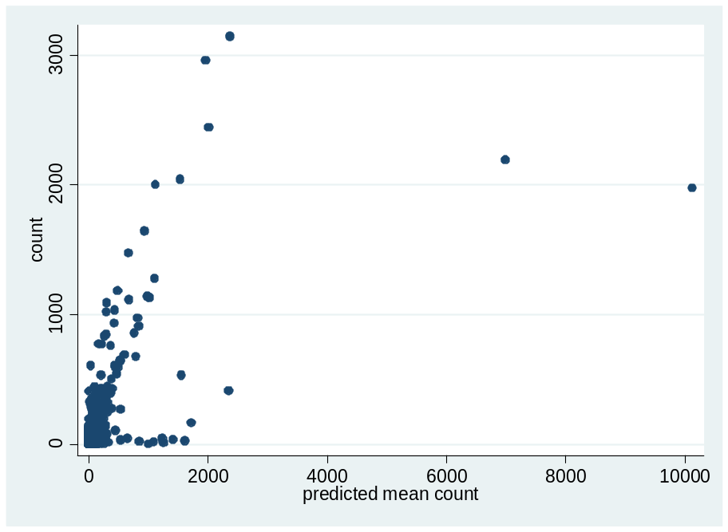
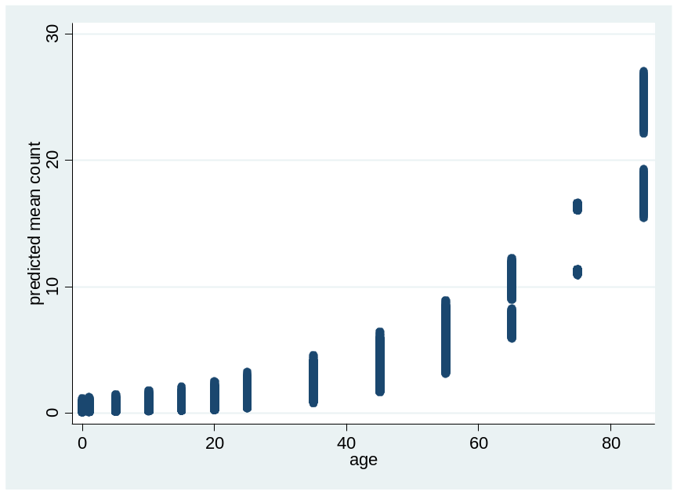

MODEL 2

. regress logitprev mage agelgdp aget sex threshold lgdp if prediction == 0

Source | SS df MS Number of obs = 1329
-------------+------------------------------ F( 6, 1322) = 557.61
Model | 10085.0659 6 1680.84431 Prob > F = 0.0000
Residual | 3984.97265 1322 3.01435147 R-squared = 0.7168
-------------+------------------------------ Adj R-squared = 0.7155
Total | 14070.0385 1328 10.5949085 Root MSE = 1.7362

------------------------------------------------------------------------------
logitprev | Coef. Std. Err. t P>|t| [95% Conf. Interval]
-------------+----------------------------------------------------------------
mage | .0693267 .0140857 4.92 0.000 .041694 .0969594
agelgdp | -.0013622 .0015973 -0.85 0.394 -.0044958 .0017713
aget | -.0003375 .0000611 -5.52 0.000 -.0004574 -.0002176
sex | -.1685851 .0997589 -1.69 0.091 -.364288 .0271178
threshold | -.0695078 .0033149 -20.97 0.000 -.0760109 -.0630047
lgdp | -.3318594 .0877845 -3.78 0.000 -.5040716 -.1596472
_cons | 2.372355 .7601216 3.12 0.002 .8811787 3.863531
------------------------------------------------------------------------------
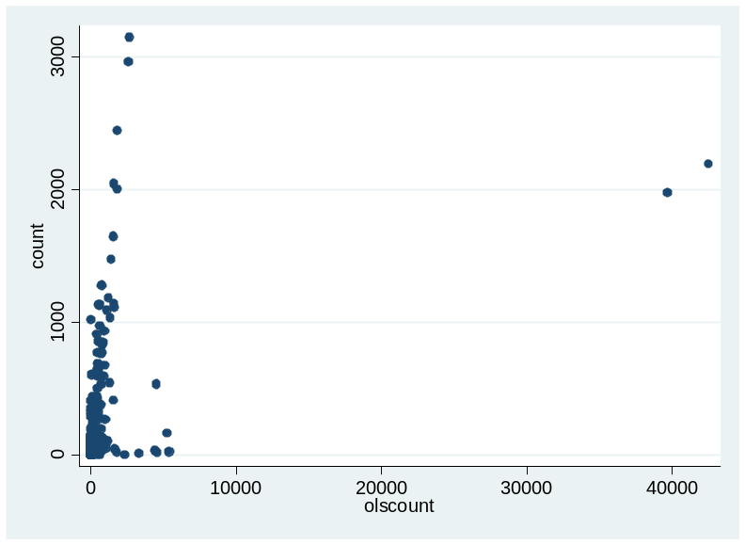

Variable | Obs Mean Std. Dev. Min Max
-------------+--------------------------------------------------------
count | 1329 69.40632 231.5129 0 3145
olscount | 1329 162.5491 1635.784 .0063637 42506.91
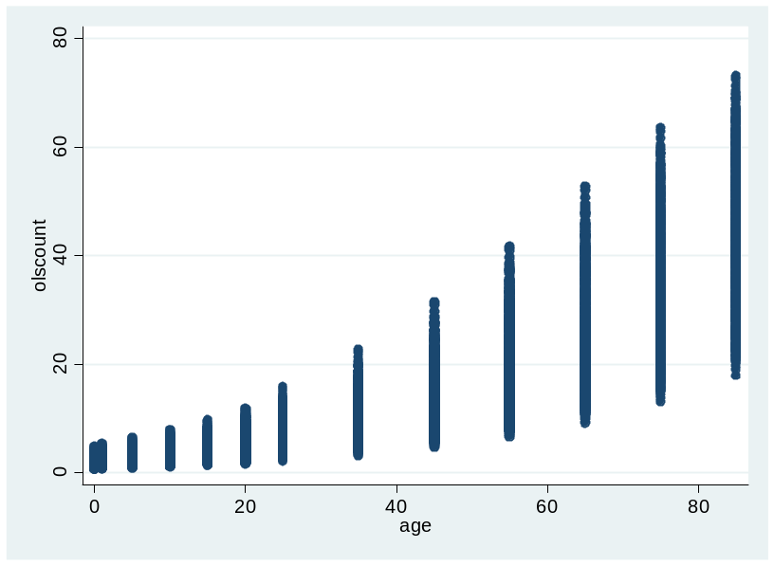

sum olscount simplecount median

Variable | Obs Mean Std. Dev. Min Max
-------------+--------------------------------------------------------
olscount | 1848 13.05017 18.40707 .1382969 88.21989
simplecount | 1848 5.577178 6.767918 .0014787 26.99337
median | 1848 5.741919 9.883743 .0149736 64.27635

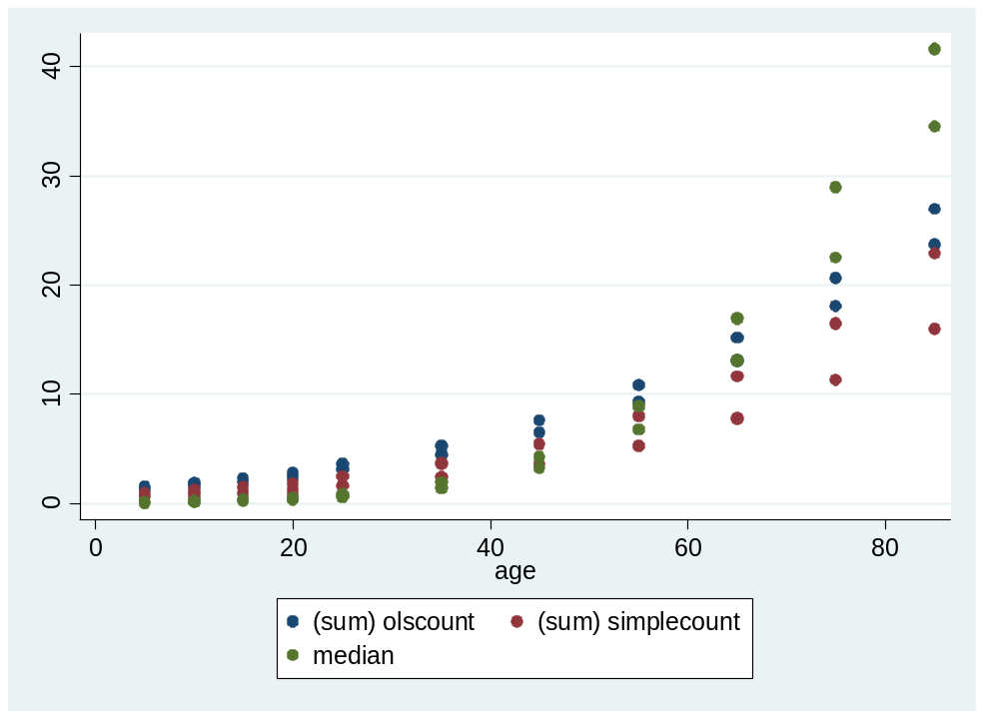
Western Europe, thresh = 50, both sexes

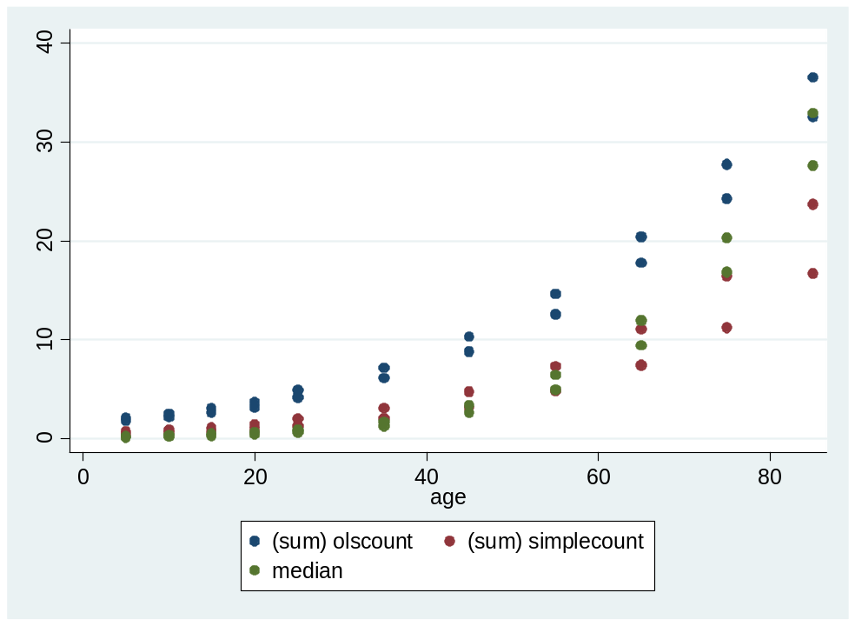
Eastern Europe, thresh = 50, both sexes
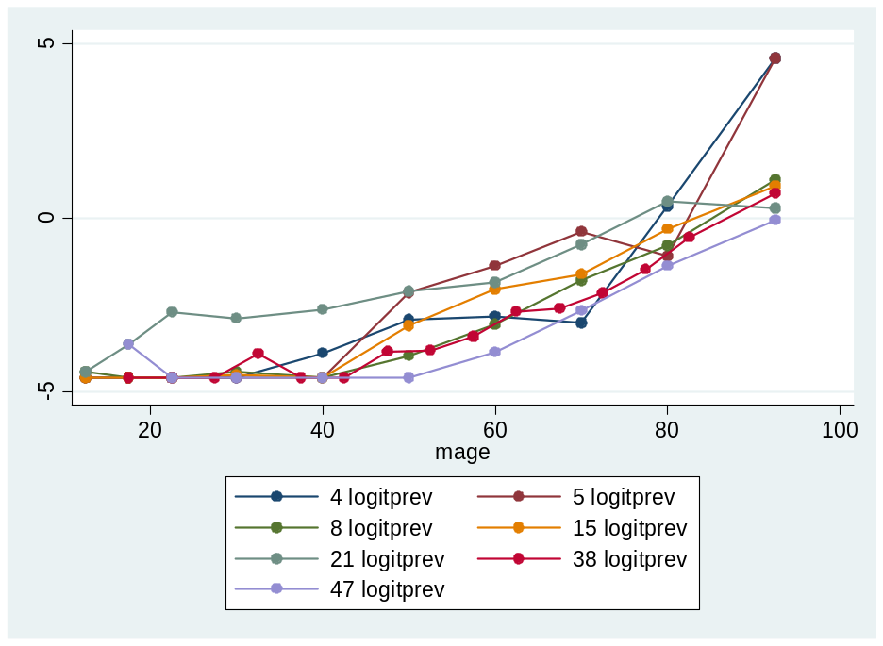
Logit of prevalence vs. age, males, threshold 50
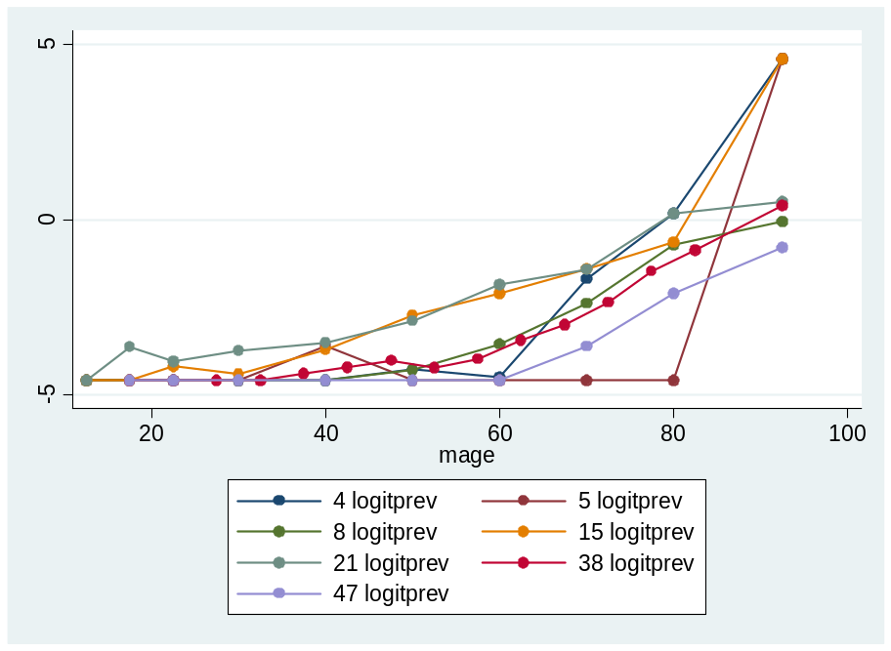
Logit of prevalence vs. age, females, threshold 50
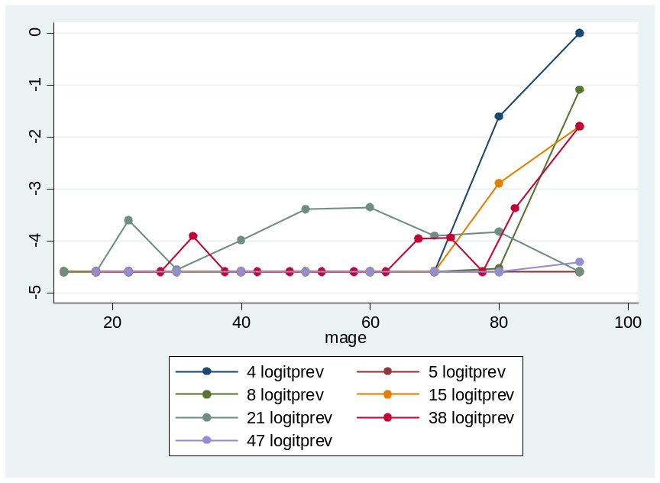
Logit of prevalence vs. age, females, threshold 80
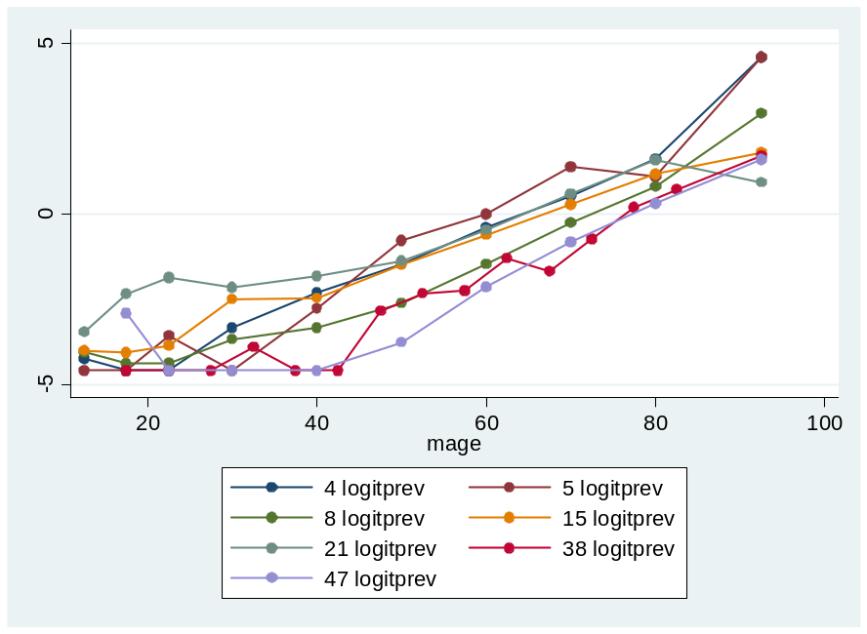
Logit of prevalence vs. age, females, threshold 35

